Abalone Creations

Abalone Creation is an organization, which provides a set of services that can lead an organization to be the best in industry. On behalf of Abalone Creations we help different organizations or group of organizations to be maintained by ourselves. Helping them to design their advertisements and giving ideas on establishment of their groups, organization or company. Ten percent of our income will be used for the social services such as charity activities. Hence being our member you will be a part of one organization as well as society too.

Website

Navigate to our website @ [www.abalonecreations.com](http://www.abalonecreations.com)

Our website tree is here

Abalone Creations

Home

Products

About us

Contact us

Navigate to Home @

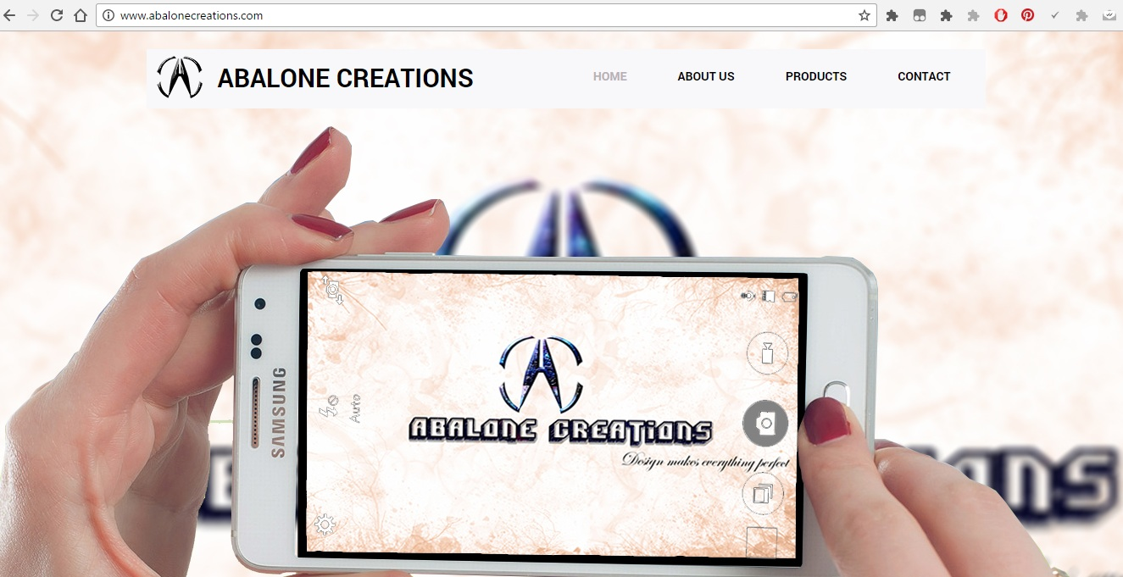[www.abalonecreations.com](http://www.abalonecreations.com )

[](http://www.abalonecreations.com )

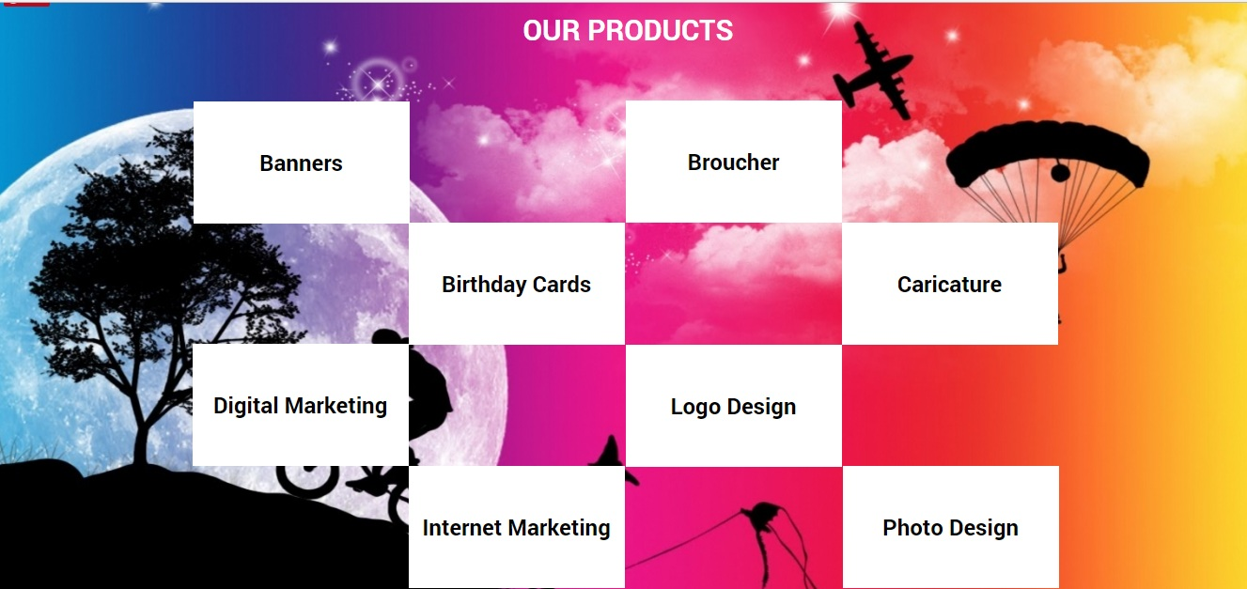



Navigate to about us @ [www.abalonecreations.com/About-us/](http://www.abalonecreations.com/About-us/)

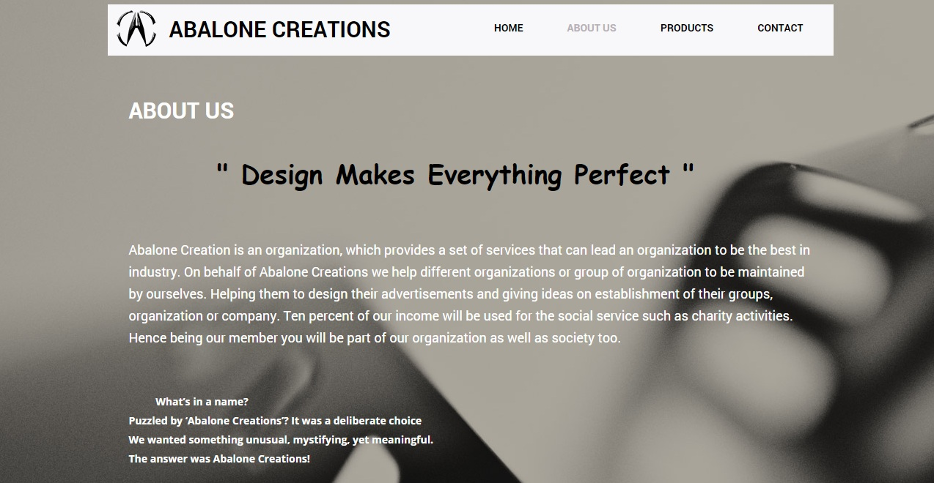

Navigate to Products @ [www.abalonecreations.com/Products/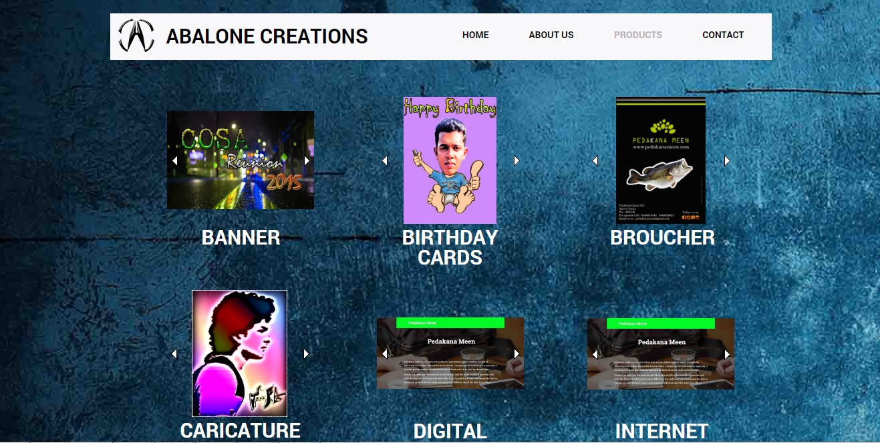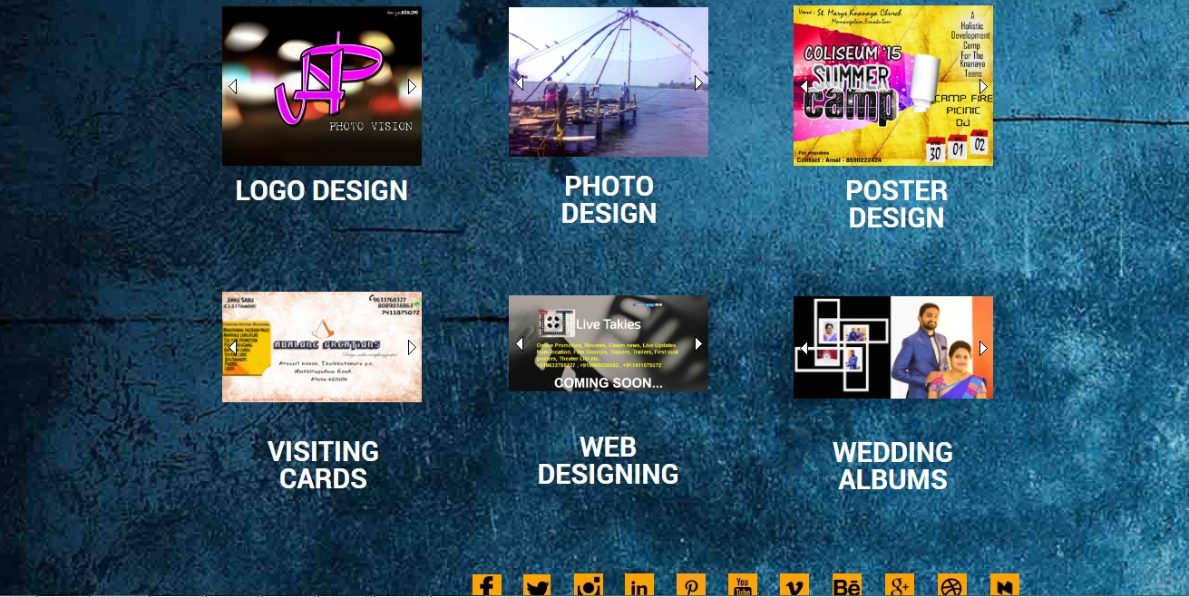](http://www.abalonecreations.com/Products/##)

Google SEO in first page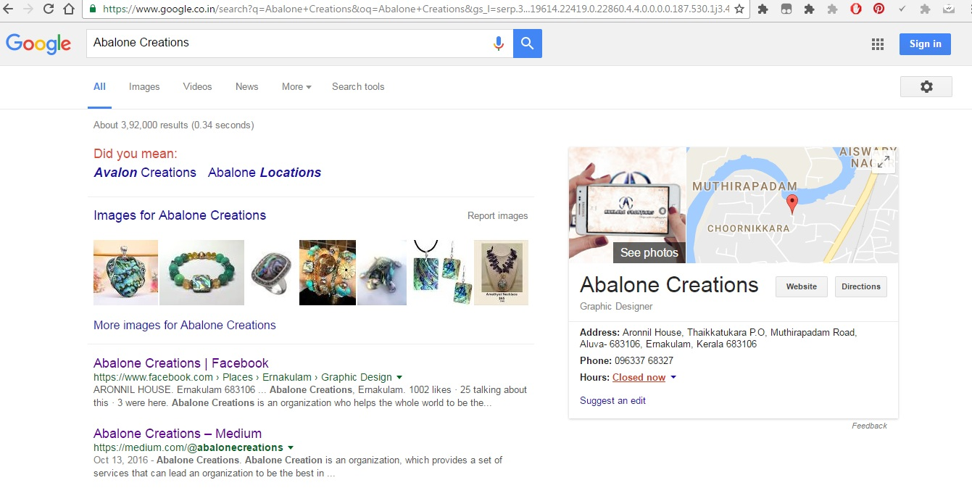

Google Analytics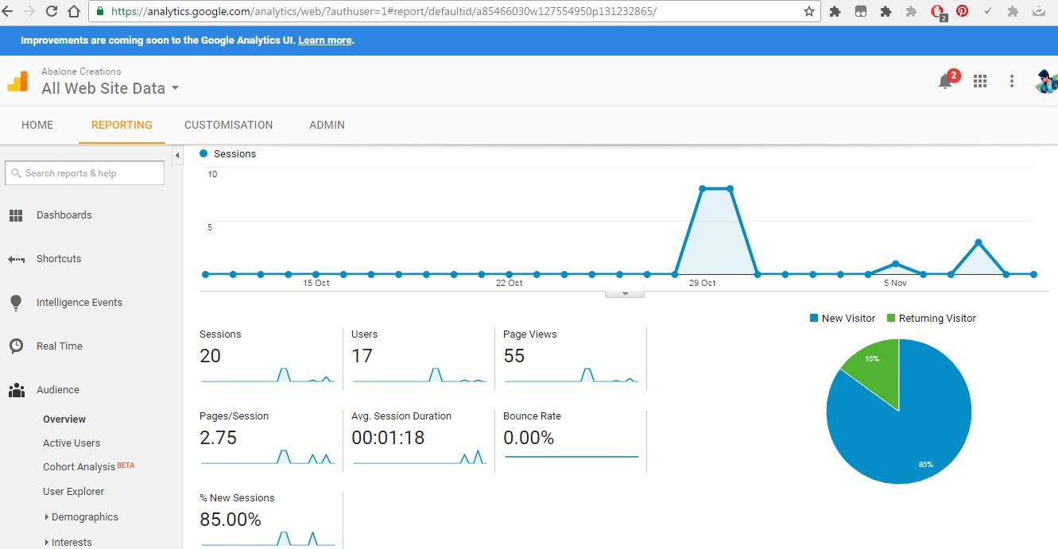

Google Ad words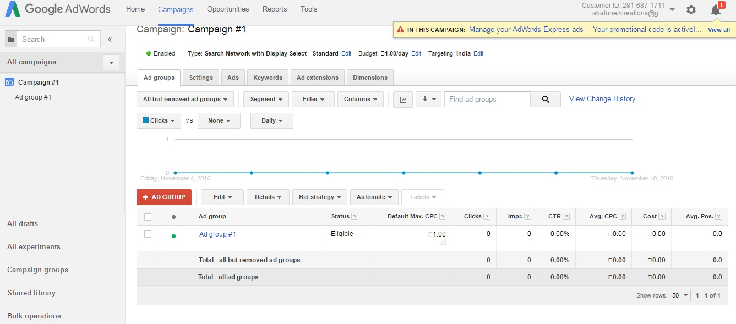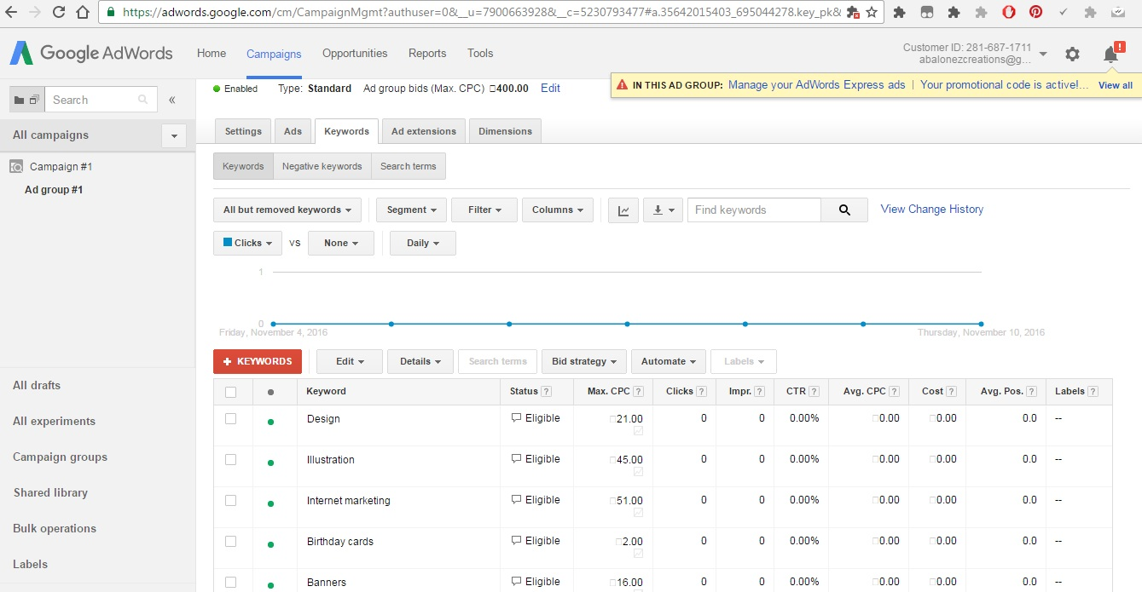

Google Webmaster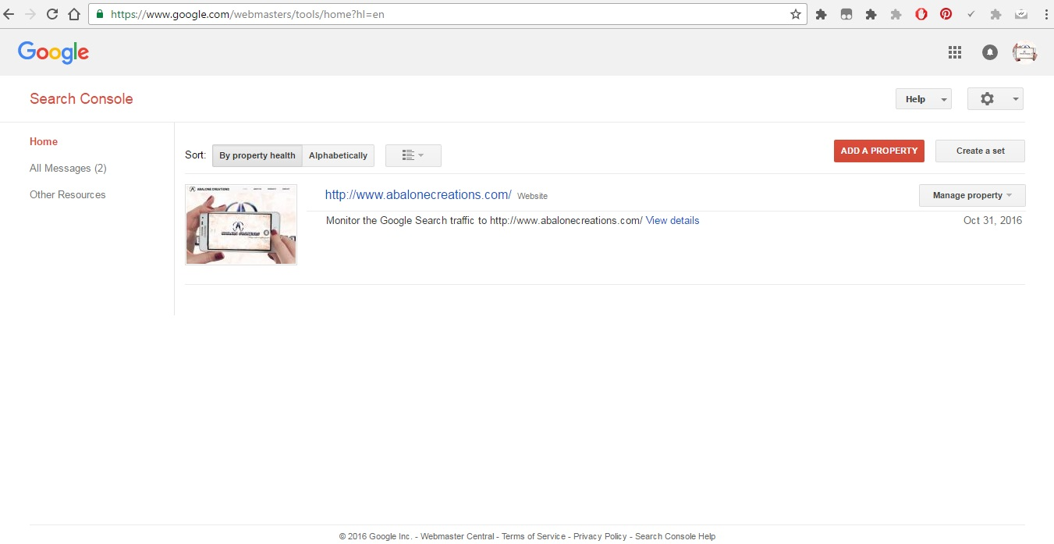

Logo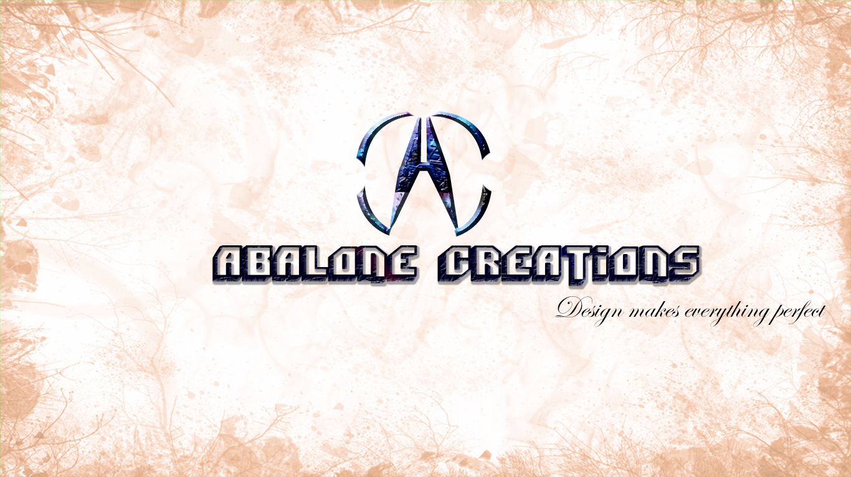

Profile Photo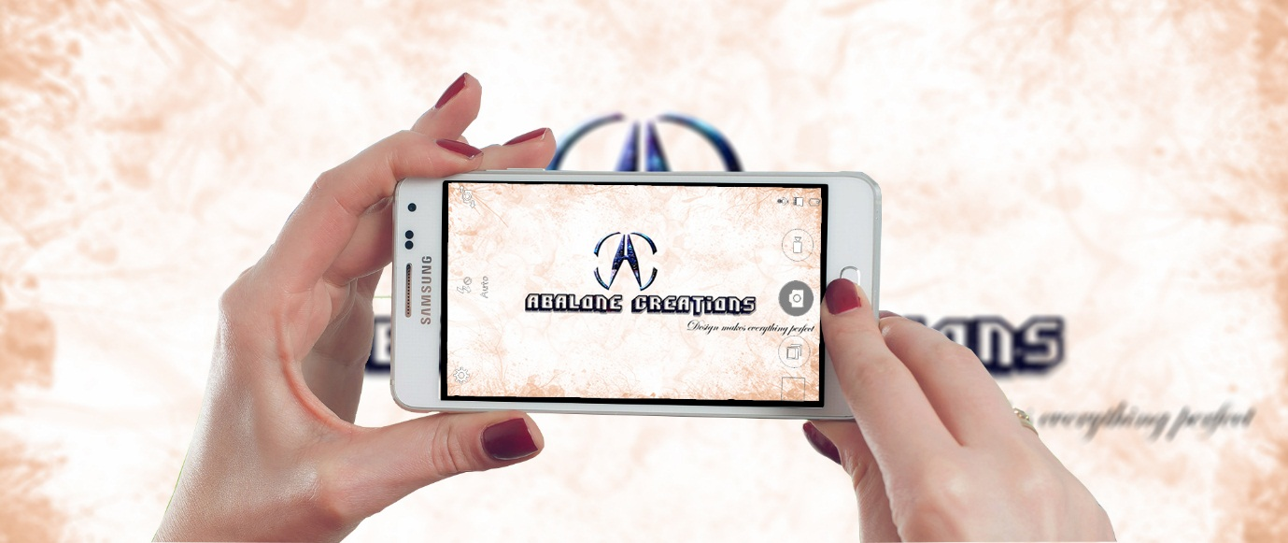

Cover photo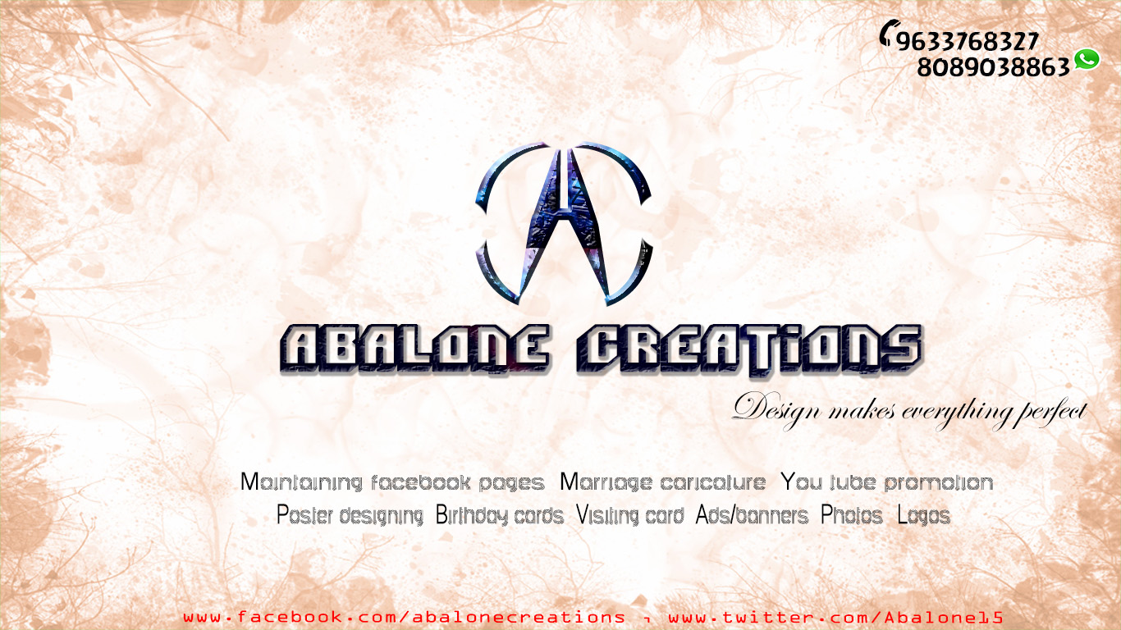

Facebook navigate @ www.facebook.com/abalonecreations/ 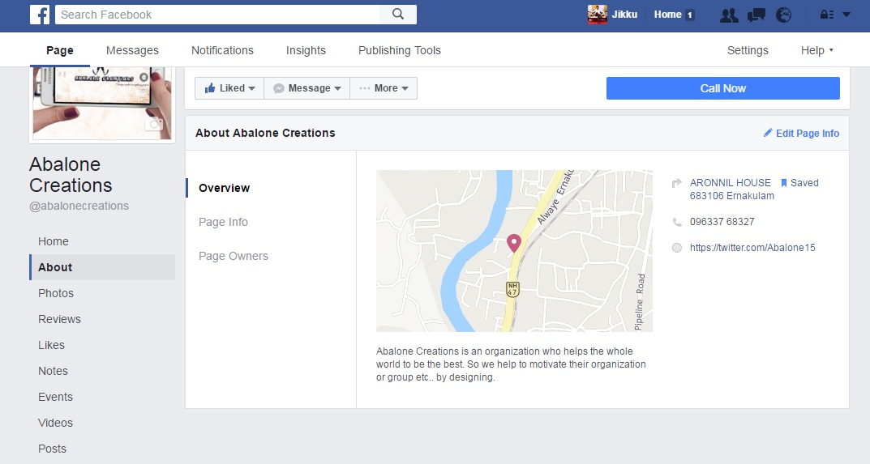

Facebook Overview navigate @ https://www.facebook.com/abalonecreations/about/?tab=overview

Facebook insight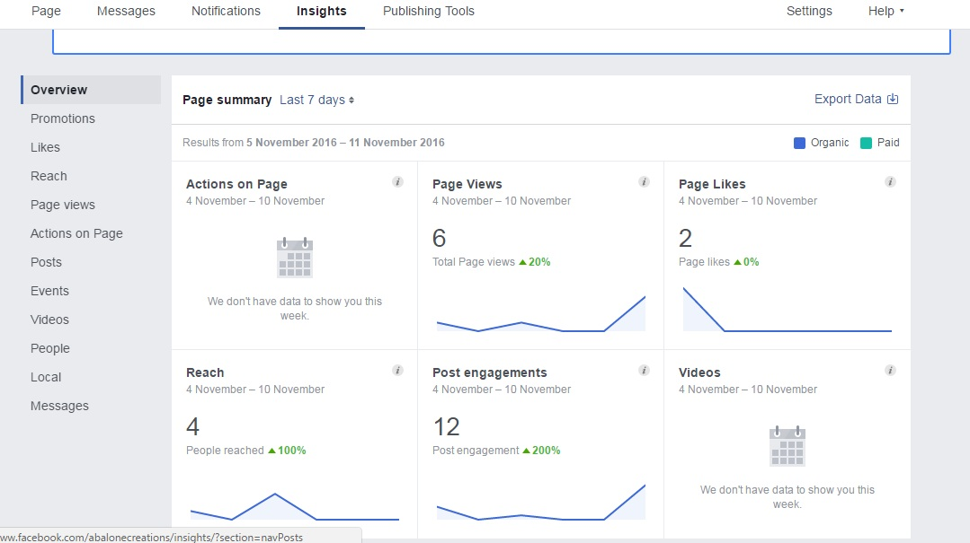

YouTube navigate @ www.youtube.com/channel/UCj6jgPnr8oH_sf3B4h0swNw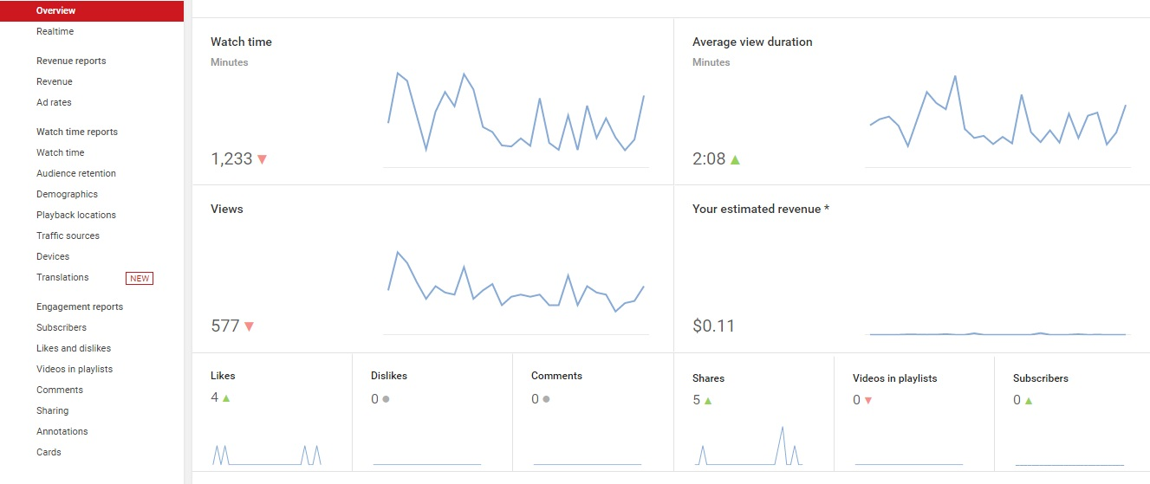

Twitter navigate @ twitter.com/Abalone15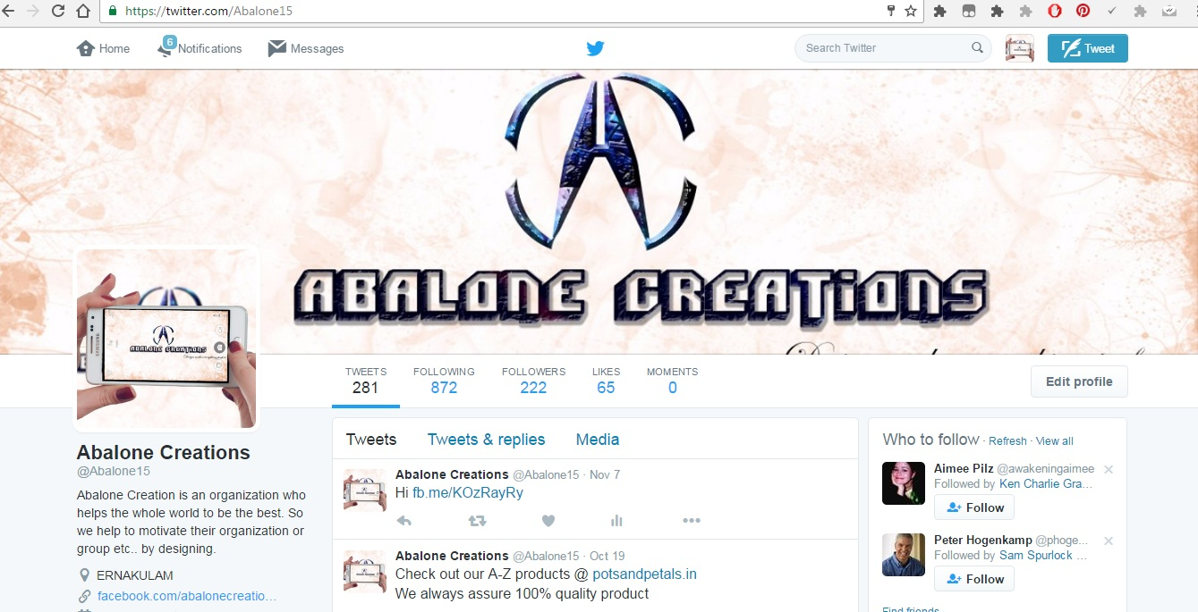

Google Plus navigate @ plus.google.com/114709609258158801490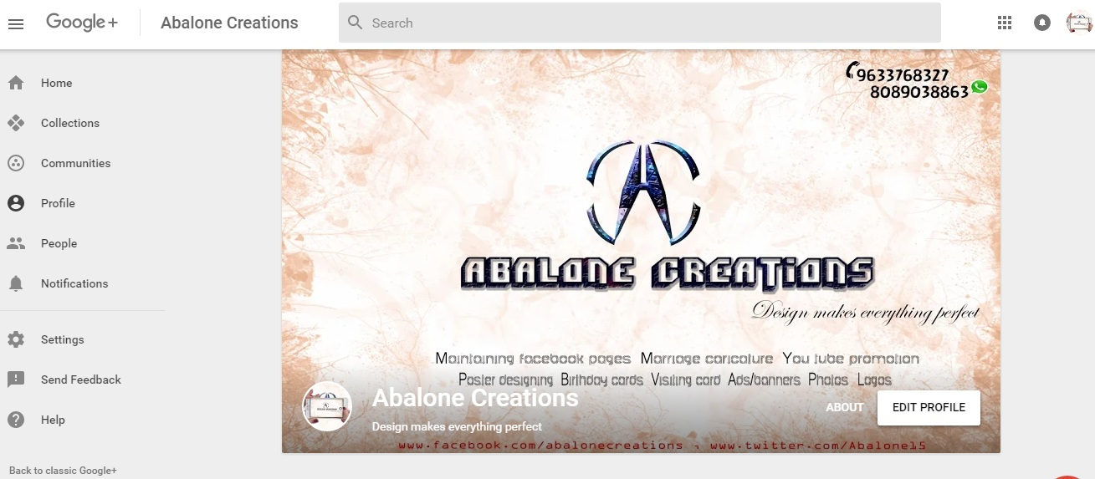

Medium navigate @ medium.com/@abalonecreations